**ACTIVITY 3**

1. Open index.html on **Chrome**

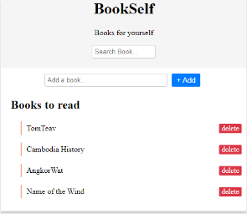

1. Open the “**Console**” tab of the developer’s tools (Ctrl + shift + I)

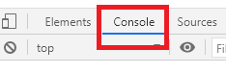

1. Execute the following instruction on console. What’s happen? Why?

document.getElementById("wrapper").textContent = "hello"

1. Restore the HTML by refreshing the page!

Write the **instruction on console** to:

1. **Change** the **title** to: **My book list**

document.getElementsByClassName("title")[0].innerHTML="My book list";

1. **Change** “TomTeav” to: **Tum Teav**

document.getElementsByClassName("name")[0].innerHTML="Tum Teav";

1. **Change** the search bar text to :  **Type here to search**

document.querySelector("input").placeholder="hello world"

1. **Hide** the text Books for yourself

document.querySelector("p").style.display= "none"

1. **Display the title in GREEN**

document.querySelector(".title").style.color="red";